City of Danville

Mayor Jerry Strause
Council Dustin Furnald
Joe Huff
Cecilia Schnathorst
Ben Heckenberg
Taylor Eisenmann

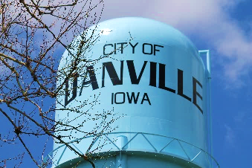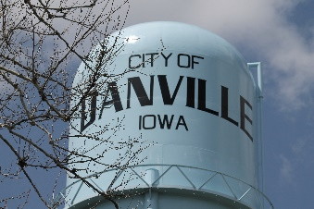
105 West Shepherd Street
PO Box 265
Danville, IA 52623
Phone: 319-392-4685
Fax: 319-392-8456
www.danvilleiowa.org

Monday, February 18, 2026

Order of business, special session

Danville City Council, Danville City Hall

NOTE: The regular session may be conducted electronically

as allowed by Iowa Code 21.8
Citizen comments: Comments must be directed to the subject under consideration. The presiding officer shall rule on the relevance of the citizen comments. Citizens making personal, impertinent, or slanderous remarks may be barred by the presiding officer from further comment before the Council during the meeting.

1. Call to order, 4:30 p.m..

2. Accept or amend the agenda.

3. Open forum: A time set aside to receive comments from the public regarding city business. The Mayor and City Council welcome comments from the public on any subject pertaining to City business, including items on this agenda. You are asked to state your name and address for the record and to limit your remarks to five minutes in order that others may be given the opportunity to speak. The Order of Business is at the discretion of the Chair. No action will be taken.

4. Discussion and action on water tower quotes.

5. Adjournment.

